Test Summary Report

Team 3
Fall 2025

Table of Contents
1. Test Summary Report Identifier (Deepesh Katudia) 3
2. Summary (Deepesh Katudia) 3
3. Testing Scope (Kiran Rathod) 4
4. Metrics (Deepesh katudia) 5
5. Types of testing performed(Swatej Mella) 10
6. Test Environments and Tools (Ayush Gehlot) 11
7. Lessons Learned (Parth Desai) 13
8. Recommendations (Parth Desai) 14
9. Best Practices (Kiran Rathod) 14
10. Exit Criteria (Swatej Mella) 15
11. Conclusion/Sign Off (Swatej Mella) 15
12. Definitions, Acronyms, and Abbreviations (Ayush Gehlot) 16

1. Test Summary Report Identifier (Deepesh Katudia)
Test Summary Report Identifier: TSR-XERO Application Module-ST-V1.0
Project Name: XERO Application Modules
Modules Tested: 09. Expense Claims, 10. Bills to Pay, 11. Accounts Payable.
Testing Level: System Testing
Report Version: 1.0
Report Date: 11/30/2025
Prepared By: Deepesh Katudia, Ayush Gehlot, Parth Desai, Swatej Mella, Kiran Rathod.

2. Summary (Deepesh Katudia)

Test Items
The following items were included in the testing activities for this cycle:
- 09. Expense Claims
- 10. Bills to Pay
- 11. Accounts Payable
These items correspond to the features identified in the approved test plan. Any variances from the planned items have been documented in the Variances section.
Environment
Testing was executed in the designated QA test environment configured according to the project’s test plan. The environment included the following components:
- Operating System: Windows OS
- Application Version: 0.1
- Browser/Device: Google Chrome
- Database:XERO
No critical variances were observed between the planned and actual environment settings.
References
The following project documents and artifacts were used as inputs for the testing cycle and support the results of this report:
- Test Plan Document
- Requirement or User Story Specifications
- Test Case Repository
- Defect Reports from <Jira/Excel/other tool>
- Build/Release Notes
These documents are maintained within the team’s configuration management repository.

3. Testing Scope (Kiran Rathod)

a) In Scope
Expense Claims:
- Submission of expense claims by users.
- Approval process for expense claims.
- Reimbursement procedures and integration with payroll.
- Validation of expense claims against company policies.
Bills to Pay:
- Creating and managing bills.
- Approval workflows for bills.
- Automation of bill entry and setup of repeating bills.
Accounts Payable:
- Creation and maintenance of supplier records.
- Viewing and managing supplier details.
b) Out of Scope
- Other application modules are assigned to other teams.
- End-to-End Testing: Testing system interfaces to external systems is out of scope as the team does not have access to the test environments of the external systems.
- Performance Testing: This includes load testing and stress testing of the system under high volumes of transactions. These tests are not conducted at this stage and could be considered in a future testing cycle.
- Security Testing: Specific security testing, such as penetration testing or vulnerability scanning, is not included in this phase of testing.
c) Items Not Tested
- Advanced Reporting Features: Some of the advanced reporting functionalities that require data from modules not covered in this testing phase (like advanced financial analytics) will not be tested.
- Third-Party App Integrations: Specific third-party applications that enhance the functionality of these modules but require separate setup or subscriptions are not tested at this stage.

4. Metrics (Deepesh Katudia)

Test Coverage for Cycle 1:

Total Requirements | Requirements Covered by  Tests
11 | 11

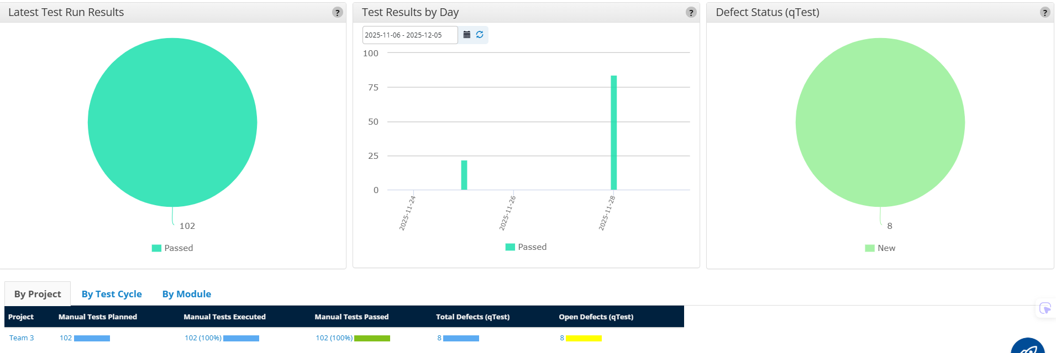

No. of test cases planned vs executed & No. of test cases passed/failed
Test cases planned | Test cases executed | TCs Pass | TCs Failed
102 | 102 | 102 | 0

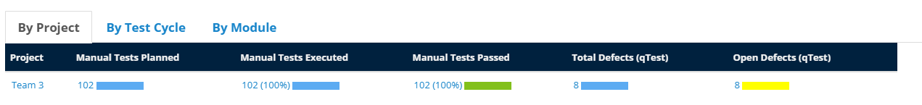
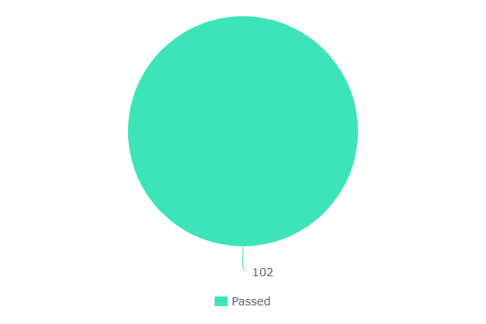
No. of defects identified
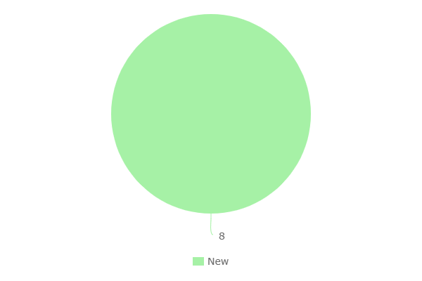

Test Coverage for Cycle 2:

Total Requirements | Requirements Covered by  Tests
6 | 6

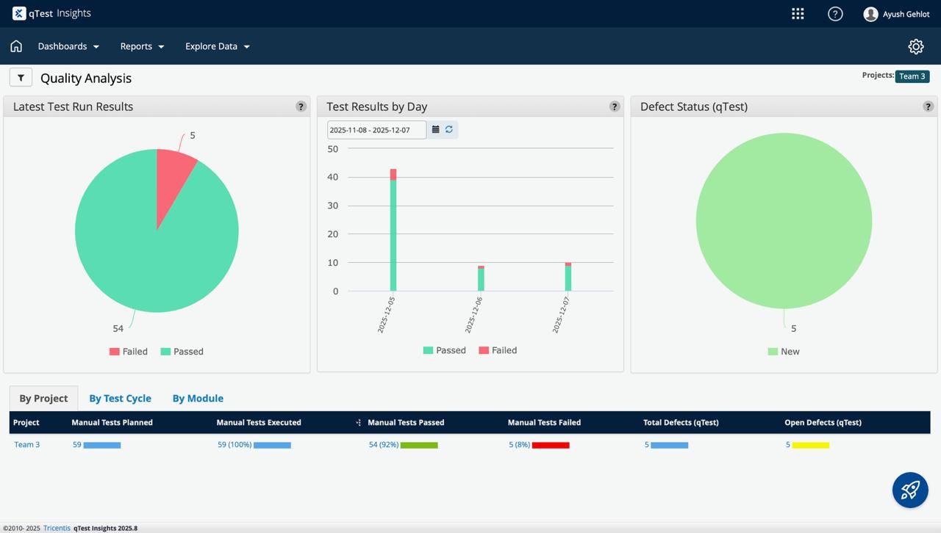

No. of test cases planned vs executed & No. of test cases passed/failed
Test cases planned | Test cases executed | TCs Pass | TCs Failed
59 | 59 | 54 | 5

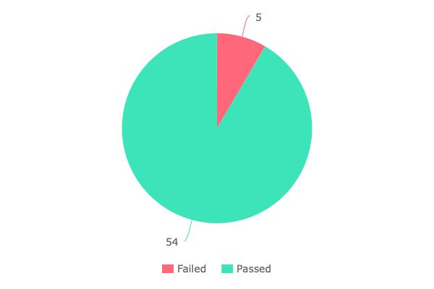
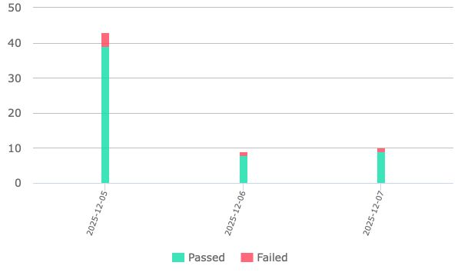
No. of defects identified
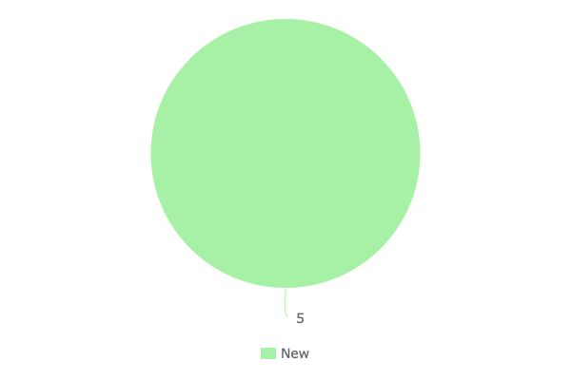

5. Types of testing performed (Swatej Mella)

The following types of testing were performed during this test cycle for the Xero Accounting System modules (Expense Claims, Bills to Pay, and Accounts Payable):

1. Functional Testing
Functional testing was carried out to validate that all core business workflows operated in accordance with documented requirements. Test cases focused on verifying key operations, including creating bills, submitting expense claims, updating supplier records, processing approvals, validating tax calculations, and checking payable balances. Each feature was assessed to ensure correctness, data accuracy, and smooth workflow transitions.

2. Integration Testing
Integration testing was performed to ensure seamless data flow among Expense Claims, Bills to Pay, and Accounts Payable modules. This helped identify issues where actions in one module (e.g., bill approval) failed to update financial data in related modules. Specific focus was given to financial postings, supplier record updates, and ledger synchronization.

3. Regression Testing
Regression testing was executed after major bug fixes and enhancements to ensure existing functionality was not impacted by code changes. A regression suite was maintained and re-executed to verify that modifications in one module did not cause unintended issues in others, particularly around approval workflows and ledger updates.

4. Usability Testing
Basic usability evaluations were conducted to verify clarity of UI elements, consistency of navigation, ease of data entry, and clarity of error messages. The goal was to ensure end-user efficiency when managing financial records and performing daily accounting tasks.

5. Validation Testing
Validation testing ensured correctness of business rules, including payable totals, tax computations, reimbursement amounts, and duplicate entry detection. Financial validation checks were prioritized because accuracy in accounting workflows is critical to production stability and reporting accuracy.

6. Test Environment & Tools (Ayush Gehlot)
The testing activities for the Expense Claims, Bills to Pay, and Accounts Payable modules were executed in the designated QA environment configured for this project. The environment closely replicated the production setup to ensure accurate validation of functional and financial workflows. The details of the testing environment and tools used are as follows:
Server Environment
The application was accessed through a cloud-hosted environment configured with the necessary backend components:
- Server Type: Virtual Private Server (VPS)
- Operating System: Linux CentOS / Ubuntu Server
- Configuration: 8 vCPUs, 16GB RAM, 200GB SSD Storage
- Hosting Location: Cloud Datacenter (Project-assigned QA environment)
Application and Database
- Application URL: https://www.xero.com (testing performed in a demo/sandbox version)
- Application Version: 0.1 (Test Build)
- Database: MySQL 8.0 (configured with financial and transactional tables required for Xero modules)
- Environment Type: QA / Sandbox
- Access Credentials: Provided to the QA team for module-level testing
Client Environment
- Browsers Used: Google Chrome (Primary), Mozilla Firefox
- Operating System: Windows OS (Tester System)
Testing Tools
- Test Management Tool: qTest (Tricentis) – used for creating, organizing, and executing test cases
- Defect Management Tool: Jira – used for reporting, tracking, and managing defects
- Documentation Repository: GitHub – used for storing test cases, reports, and execution logs
- Communication Tools: Slack / Teams – used for daily updates, clarifications, and collaboration
The selected environment and tools ensured consistent test execution, accurate defect reporting, and efficient collaboration among the QA and development teams.

7. Lessons Learned (Parth Desai)

S. No | Issues faced | Solutions
1 | Dependencies between the three modules were not clearly understood at the beginning (e.g., Bills to Pay affecting Accounts Payable balances) | Conduct module walkthroughs before testing begins. Understanding workflow connections (Bill entry → Approval → Posting in Accounts Payable) helps the team test end-to-end functionality more effectively.
2 | Test data preparation was time-consuming for all modules, especially Expense Claims requiring receipts and Bills to Pay requiring vendor data | Prepare standardized test data sets ahead of time for each module. Creating reusable claim receipts, bill samples, and vendor profiles reduces delays and ensures consistent test coverage.
3 | High number of defects appeared in integration areas (e.g., approved Bills not reflected in Accounts Payable) | Create dedicated integration test cases early. Testing module-to-module communication (Expense Claims → Payables, Bills → Ledger updates) reduces late-cycle rework and improves overall system stability.
4 | Some team members did not fully understand how financial calculations (tax, totals, payable balances) worked | Include functional knowledge sessions focusing on financial rules used by the Xero modules. Clear understanding of tax calculations, reimbursement rules, and ledger postings improved test accuracy.
5 | Communication gaps during parallel testing of the three modules caused duplicate test coverage and missed updates | Establish daily stand-ups and shared test progress tracking. A unified communication channel ensures clarity on who is testing what and prevents redundant efforts
6 | Regression testing became difficult because changes in one module affected another (e.g., AP updates impacting Bill workflows) | Maintain a regression suite specifically for interconnected workflows. Running regression after each major fix ensures no unintended side effects across modules.

8. Recommendations (Parth Desai)

- Create a clearly defined end-to-end workflow diagram showing how Expense Claims, Bills to Pay, and Accounts Payable are connected. This helps testers quickly understand data flow before testing begins.
- Introduce an early Integration Testing phase to verify that actions in one module properly update the other modules, reducing the number of late-cycle defects.
- Encourage cross-module knowledge sharing so each tester is familiar with how financial postings work. This improves accuracy when validating Accounts Payable updates.
- Use regular communication checkpoints (brief stand-ups, progress summaries) to coordinate testing across the three modules and avoid redundant or overlooked test cases.
- Prepare structured and reusable test data sets to eliminate delays during future test cycles.

9. Best Practices (Kiran Rathod)

Before beginning the testing activities, we prepared detailed test case documents outlining the test scenarios and their expected outputs. This documentation served as the foundation for executing the tests within the Tricentis qTest platform. Using qTest, we systematically executed the test cases, tracked the results, and maintained execution logs to ensure accuracy, traceability, and consistency throughout the testing cycle.

10. Exit Criteria (Swatej Mella)
The following exit criteria were used to determine readiness for completion of the test cycle:
- 100% of planned test cases were executed across all three modules (Expense Claims, Bills to Pay, and Accounts Payable).
- All Critical, Major, and Medium defects were identified, fixed, and successfully re-tested before closure.
- No unresolved defects of high business impact remain open at the conclusion of the test cycle.
- All test deliverables, including test cases, execution results, and defect reports, were reviewed and documented in the test repository.
- Regression testing was completed successfully after the latest round of fixes to ensure system stability.
- Stakeholders reviewed and approved the testing results, indicating that quality expectations have been met.
- If any Low priority or minor cosmetic defects remain, an action plan and timeline have been provided for resolution in future release cycles.

11. Conclusion/Sign Off (Swatej Mella)

Based on successful completion of the testing activities and fulfillment of the exit criteria, the testing team concludes that the Expense Claims, Bills to Pay, and Accounts Payable modules are stable for release to the next phase.
All core business scenarios have been validated and verified, with zero outstanding high-severity defects remaining open. Test results demonstrate that the system functions as expected, financial workflows are accurate, and all business rules operate correctly across modules.
It is recommended that the application proceed to User Acceptance Testing (UAT) to obtain final business confirmation prior to deployment. Provided UAT feedback is addressed, the overall application quality is considered acceptable for production rollout and stakeholder approval.

12. Definitions, Acronyms, and Abbreviations (Ayush Gehlot)

- qTest: A test management tool used to create test cases, execute test cycles, manage test results, and track coverage throughout the testing lifecycle.
- JIRA: A defect and project tracking tool used by the QA team to report bugs, assign priorities, monitor defect resolution, and manage workflow processes.
- UAT: The final validation phase where end-users evaluate the application to ensure it meets business needs before deployment.
- URL: The web address used to access the application being tested.
- QA (Quality Assurance): The practice of ensuring software quality through systematic testing, defect detection, and adherence to standards.
- Defect: Any deviation between the expected and actual behavior of the application discovered during testing.
- Test Environment: A dedicated setup of software, hardware, network, and database configurations used strictly for testing activities.
- Test Data: Sample data created or prepared to validate different scenarios (e.g., expense receipts, vendor bills, payable entries).

